A2 Individual
Word Count: 243+213 = 456

Participant 1:
Name: Rue
Age: 23
Major: MPS Information Science
Background: Rue is a first-year graduate student from China. She lives in an apartment where she has access to a small kitchen. Rue is a self-declared “microwave master” since she heavily relies on her microwave for cooking most of her meals, including breakfast and dinner. She enjoys the convenience of microwave cooking, using it to prepare various types of meals, such as Chinese mantou (bread), matcha-infused bread, and other quick dishes.

Interview Context:
The interview was conducted in Rue's apartment kitchen, with a brief tour of her dining area where she often enjoys her meals. The setting was a small, functional kitchen with a microwave and minimal cookware. Rue showed various cooking tools, such as her microwave and some simple utensils, and her handwritting recipe record and pictures of meals. She also mentioned relying on minimal ingredients and making meal decisions while shopping. The apartment was neat, and she mentioned using the microwave as her primary cooking tool due to time efficiency and ease of cleaning.

Key Takeaways:
Rue’s cooking habits center around speed and convenience. She prefers the microwave because it allows her to quickly prepare meals with minimal cleanup. Her goal is to create meals that are both visually appealing and emotionally satisfying, which boosts her mood for the day. This suggests an opportunity for a cooking app that focuses on quick, personalized recipes that can be made using minimal equipment like a microwave.

Photos:
Access to the kitchen, small pot, cups and dishes

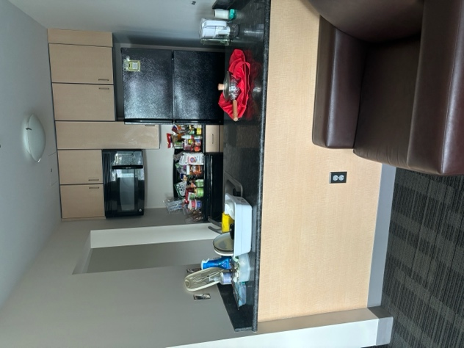
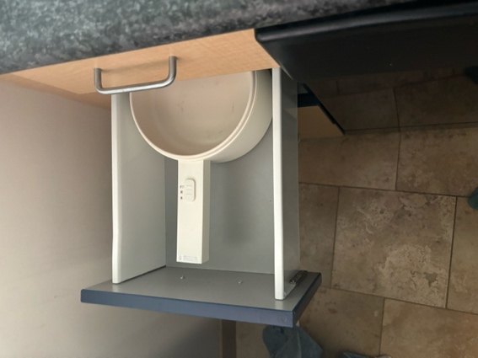
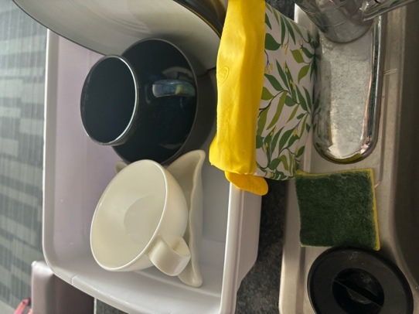

Quick heat-up Matcha Powder, Bread for today’s breakfast, handdrawing recipe

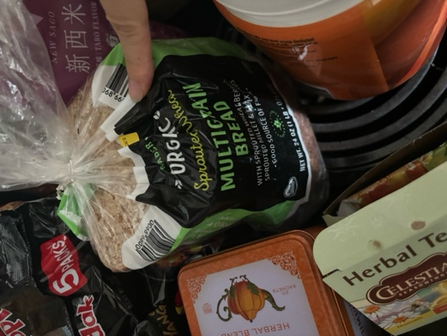
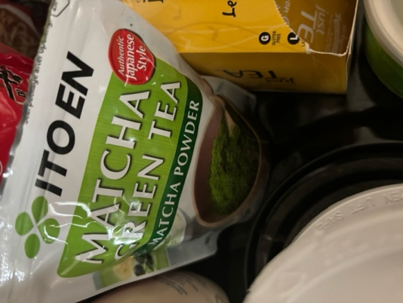
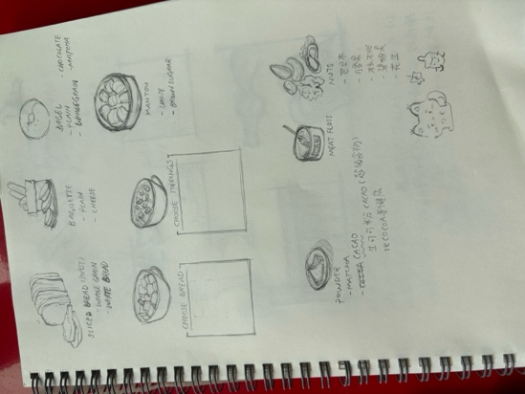

Shared meal picture on social media

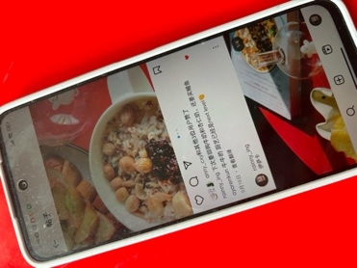
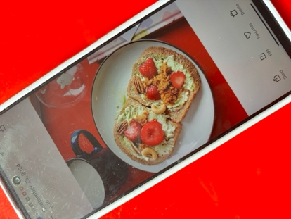

Participant 2:
Name: Astoria
Age: 23
Major: Law
Background: Astoria is a second-year JD program law student from Massachusetts. She lives in a shared five-bedroom apartment and cooks about three times a week. Astoria mostly prepares simple meals using non-perishable ingredients like pasta, rice, and beans. She prefers quick, easy meals due to her busy schedule and often relies on pre-packaged foods to save time.

Interview Context:
The interview took place in Astoria’s shared apartment kitchen, which was equipped with essential tools such as an electric kettle, toaster, and pot. The kitchen was small but well-organized, reflecting Astoria’s need for efficiency. Astoria showed various items she uses, such as her kettle and rice cooker.

Key Takeaways:
Astoria’s cooking is shaped by her time constraints and the need for simplicity. She often makes meals that are quick and involve non-perishable ingredients to avoid frequent grocery shopping. Her primary reason for cooking is to save money, as takeout is expensive, and she enjoys the simplicity of meals that can be prepared in about 30 minutes. Astoria typically prepares multiple portions at once to minimize cooking time throughout the week. This highlights the potential for a cooking app that offers quick recipes based on pantry staples, particularly for people with limited time and energy for cooking.

Photos:
Cutting board, water bottle and toaster, knives and forks

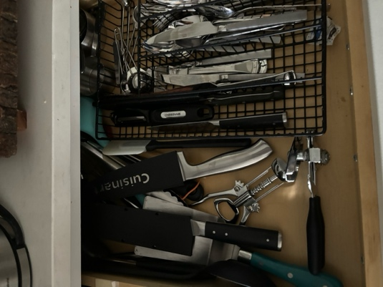
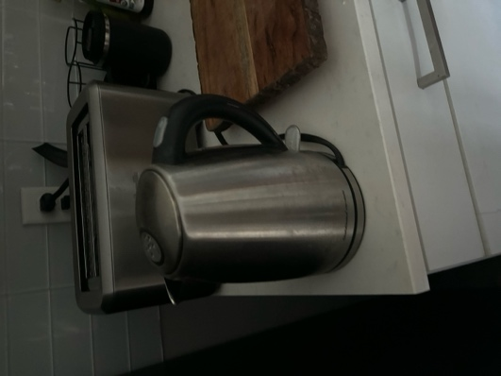
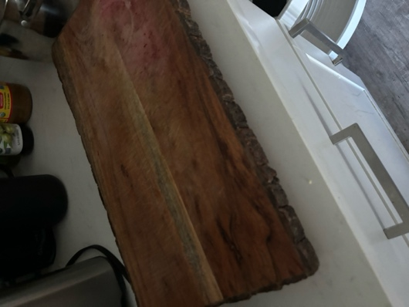

Ingredients and plates, boxed soup, open-to-eat carrot

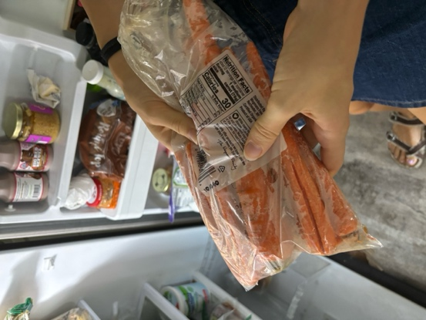
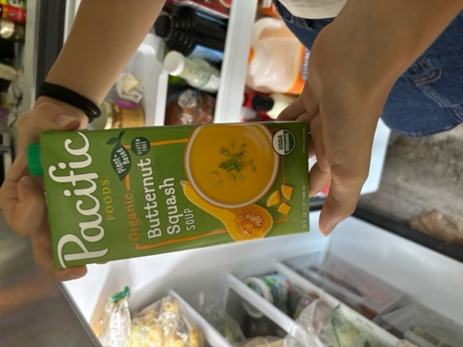
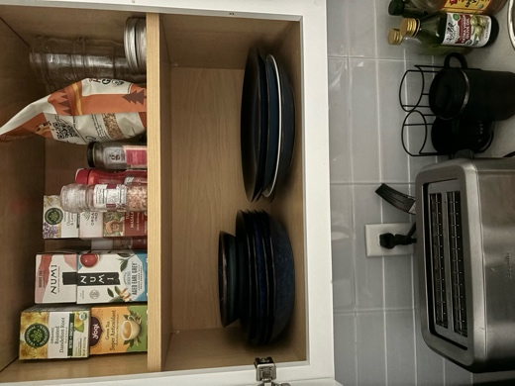

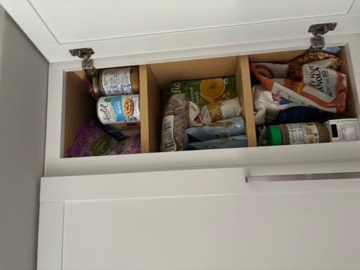
Can food

TurboScribe Link:
Interviewee 1: https://turboscribe.ai/transcript/share/3936146074327395565/8b6RGLSQ4L5YcJDBIPoWg2bPR_ws9ZKa8khCeY2yxKk/interviewee-1

Interviewee 2: https://turboscribe.ai/transcript/share/3936146074327395918/91ROO9evNyOayHWViv602DxS9T6ioS7IHteqbu4GSZs/interviewee-2

Activity Notes Spreadsheet:
https://docs.google.com/spreadsheets/d/1J9qgxCPrCdCkF6_5iTqCabfL481ztYJLyaZLV4sAYT8/edit?gid=0#gid=0

Appendix:
Interview Protocol: https://docs.google.com/document/d/1JtoTrd5xubO1ibCY2gF6pK1JFxBySd9CsurGv9qb7cM/edit#heading=h.acpr6dwkbm20

Interview Questions: https://docs.google.com/document/d/1angJ1DkIzV4I1Rc60q0i_ekXwnyDGsLe0yIaiyKZxGI/edit

Consent Form: https://docs.google.com/document/d/1lKXhdfGsT6fVPWpv-tq10BMleXrfxjNnfobeBr0DZoU/edit#heading=h.txvw7zlzh9mw

